|  |  |  |  |  |
| --- | --- | --- | --- | --- |
| National University of Computer and Emerging Sciences, Lahore Campus | | | | |
| final design | **Course:** | **OOAD Lab** | **Course Code:** | **CS-309** |
| **Program:** | **BS(Computer Science)** | **Semester:** | **Fall 2018** |
| **Duration:** | **50 minutes** | **Total Marks:** | **10** |
| **Quiz Date:** | **12-Nov-2018** | **Weight** | **5** |
| **Section:** | **A** | **Page(s):** | **1** |
| **Exam:** | **Quiz 1** | **Roll No:** |  |

Consider a reservation system for an inter-city transportation company that operates buses on

different routes. Each route is determined by a source and destination. On each route different

buses run at different timings. There are two categories of buses that differ in services and

consequently fare. Economy buses provide standard transportation facility and their fare is

computed as a product of the route distance and base rate (fare per km). Luxury buses on the

other hand have a higher base rate, considering reduced seating capacity. In addition, luxury

buses provide different options for refreshments as well as extra luggage, the cost of which can

be added to the fare.

**Q1:** UML diagram of a system called FAST AUTO MOTORS is given bellow. You need to implement that system in JAVA. You can add method/functions but do not add any attribute in any class and do not change relationship between classes. Size function will print Size of car, and color function will print color of bike.The relationship between Car_ShowRoom and Car and Bike_ShowRoom and Bike is a simple association. For our test program Micro car size is 10, compact Car size is 15 and SubCompact Car size is 20. A driver program is also given, your code should run that driver program.

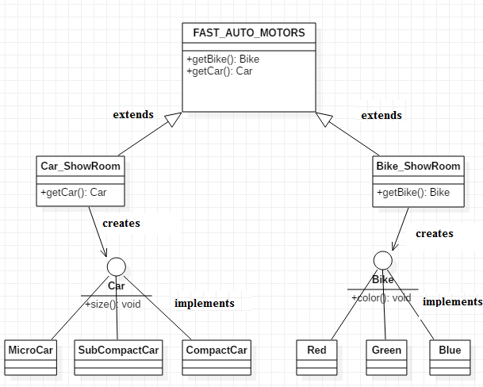

|  |  |
| --- | --- |
| **Driver.java**  public class Driver  {  public static void main(String[] args)  {  FAST_AUTO_MOTORS m = new Car_ShowRoom();  Car car = m.getCar("Micro Car"); //This will print “ you ordered a Micro car in constructor.  car.size();  m=new Bike_ShowRoom();  Bike bike = m.getBike("Blue"); //This will print “ you ordered a blue bike in constructor.  bike.color();  bike = m.getBike("Red");  bike.color();  m=new Car_ShowRom();  car = m.getCar("Compact Car");  car.size();  }  } | Sample Output:  You ordered a Micro car  Micro car size is 10  You ordered a blue bike  Bike color is blue  You ordered a red bike  Bike color is red  You ordered a Compact car  Compact car size is 15 |